Assignment 4

**1**

Clock = 592.067 -> 598.7641 (timeDiff = 6.69704)

Event = D (Next = A)

Future events = (D, 604.067)

state(LS = 1, LQ = 0)

stats(N = 51, NW = 28, WS = 150.1097, WQ = 57.34694, T0 = 202.067, Tmax = 352.1767)

Clock = 598.7641 -> 600 (timeDiff = 1.235935)

Event = A (Next = E)

Future events = (A, 613.8851)

state(LS = 1, LQ = 1)

Clock = 600 -> 604.067 (timeDiff = 4.067025)

Event = E (Next = D)

Future events = no new events generated

state(LS = 1, LQ = 1)

stats(N = 52, NW = 29, WS = 150.1097, WQ = 57.34694, T0 = 202.067, Tmax = 352.1767)

stats(N = 52, NW = 29, WS = 150.1097, WQ = 57.34694, T0 = 202.067, Tmax = 352.1767)[1] ""

**2b)**

stats(N = 60, NW = 45, WS = 260.3632, WQ = 389.5145, T0 = 125.6576, Tmax = 386.0208)[1] ""

stats(N = 49, NW = 29, WS = 136.5669, WQ = 149.7464, T0 = 244, Tmax = 380.5669)[1] ""

stats(N = 54, NW = 36, WS = 199.9707, WQ = 279.221, T0 = 190, Tmax = 389.9707)[1] ""

stats(N = 58, NW = 48, WS = 266.5218, WQ = 280.5069, T0 = 125.9207, Tmax = 392.4426)[1] ""

stats(N = 55, NW = 37, WS = 240.668, WQ = 248.0893, T0 = 179.7355, Tmax = 420.4035)[1] ""

stats(N = 51, NW = 27, WS = 159.8932, WQ = 88.51104, T0 = 229, Tmax = 388.8932)[1] ""

stats(N = 65, NW = 44, WS = 232.3971, WQ = 491.1405, T0 = 111.8197, Tmax = 344.2168)[1] ""

stats(N = 50, NW = 35, WS = 206.3235, WQ = 321.2266, T0 = 218.3989, Tmax = 424.7224)[1] ""

stats(N = 39, NW = 20, WS = 125.4985, WQ = 80.0359, T0 = 284.1613, Tmax = 409.6598)[1] ""

stats(N = 55, NW = 36, WS = 173.7071, WQ = 214.2349, T0 = 178, Tmax = 351.7071)[1] ""

**100X**

stats(N = 51, NW = 32, WS = 160.1432, WQ = 244.4191, T0 = 215.9519, Tmax = 376.0952)[1] ""

stats(N = 47, NW = 23, WS = 134.974, WQ = 58.32246, T0 = 275.868, Tmax = 410.842)[1] ""

stats(N = 57, NW = 35, WS = 197.2358, WQ = 202.3788, T0 = 160.805, Tmax = 358.0408)[1] ""

stats(N = 39, NW = 19, WS = 102.4914, WQ = 130.1576, T0 = 309, Tmax = 411.4914)[1] ""

stats(N = 49, NW = 22, WS = 118.4169, WQ = 42.93681, T0 = 259.5778, Tmax = 377.9947)[1] ""

stats(N = 48, NW = 25, WS = 147.7946, WQ = 72, T0 = 259, Tmax = 406.7946)[1] ""

stats(N = 47, NW = 28, WS = 150.5342, WQ = 161.932, T0 = 273.6594, Tmax = 424.1936)[1] ""

stats(N = 69, NW = 58, WS = 268.4767, WQ = 434.3771, T0 = 99.32749, Tmax = 367.8042)[1] ""

stats(N = 52, NW = 30, WS = 163.3469, WQ = 119.5703, T0 = 233.4124, Tmax = 396.7593)[1] ""

stats(N = 49, NW = 34, WS = 180.5536, WQ = 235.3747, T0 = 196, Tmax = 376.5536)[1] ""

**1000x**

stats(N = 58, NW = 35, WS = 153.4149, WQ = 131.6165, T0 = 213.3635, Tmax = 366.7784)[1] ""

stats(N = 45, NW = 25, WS = 137.0019, WQ = 162.1085, T0 = 280, Tmax = 417.0019)[1] ""

stats(N = 55, NW = 35, WS = 161.9579, WQ = 286.1352, T0 = 220, Tmax = 381.9579)[1] ""

stats(N = 46, NW = 26, WS = 122.1191, WQ = 145.3524, T0 = 282.2877, Tmax = 404.4068)[1] ""

stats(N = 53, NW = 40, WS = 213.8976, WQ = 435.8942, T0 = 208, Tmax = 421.8976)[1] ""

stats(N = 49, NW = 30, WS = 155.8679, WQ = 84.26264, T0 = 236.8008, Tmax = 392.6686)[1] ""

stats(N = 57, NW = 34, WS = 212.2134, WQ = 150.2047, T0 = 155.664, Tmax = 367.8774)[1] ""

stats(N = 48, NW = 31, WS = 191.5716, WQ = 192.3998, T0 = 229, Tmax = 420.5716)[1] ""

stats(N = 56, NW = 40, WS = 185.0506, WQ = 203.3916, T0 = 198.8024, Tmax = 383.8531)[1] ""

stats(N = 45, NW = 24, WS = 155.4008, WQ = 134.3796, T0 = 256.7989, Tmax = 412.1997)[1] ""

**B)**

The average of Idle time (T0) is 10x(188.3) 100x(227.8) 1000x(217.7)

If we take the average Idle time and divide it by the total system time (Hours in the simulation) we get: 10x(31.3%) 100x(37.8%) and 1000x(36.2%8) of the time it is idle

The probability of the Cashier being idle is 10x(3 in 10) 100x(37 in 100) 1000x(36 in 100)

**C)**

I Would assume that the Teller has a busier day, as 65% of people would visit them, while only 40% of the 65% would visit the cashier.

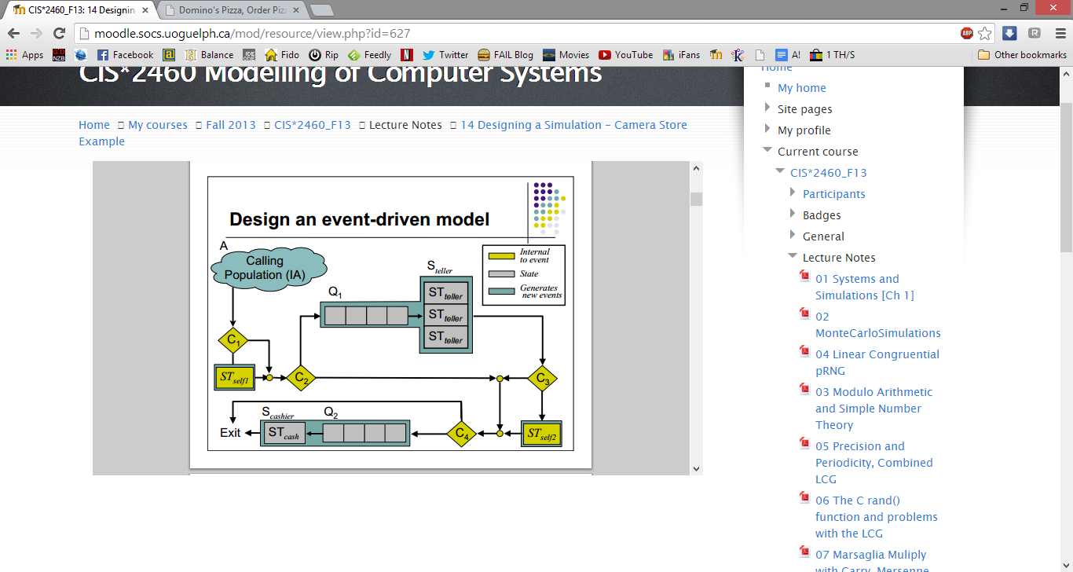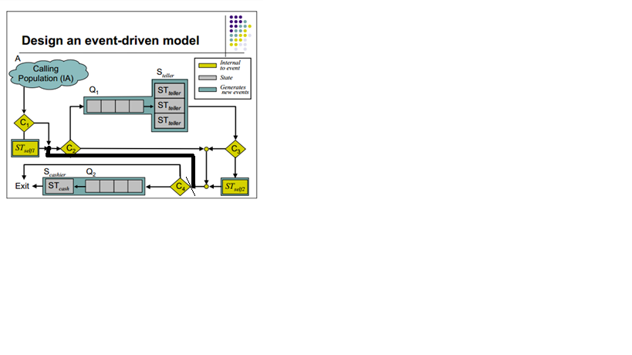3A)

P=1 P=0

**C/D**

**P=1:**

stats(N = 52, NW = 38, WS = 209.6036, WQ = 189.3354, T0 = 196.7803, Tmax = 406.3839)[1] ""

stats(N = 50, NW = 24, WS = 136.7738, WQ = 615.109, T0 = 217, Tmax = 353.7738)[1] ""

stats(N = 46, NW = 26, WS = 129.7067, WQ = 48.10114, T0 = 255.1426, Tmax = 384.8493)[1] ""

stats(N = 54, NW = 38, WS = 201.5332, WQ = 68.54374, T0 = 196.5483, Tmax = 398.0815)[1] ""

stats(N = 37, NW = 13, WS = 81.67358, WQ = 650.673, T0 = 321.5041, Tmax = 403.1776)[1] ""

stats(N = 41, NW = 21, WS = 123.7473, WQ = 602.9858, T0 = 300.6639, Tmax = 424.4112)[1] ""

stats(N = 53, NW = 36, WS = 180.4271, WQ = 136.4495, T0 = 217.0291, Tmax = 397.4562)[1] ""

stats(N = 54, NW = 27, WS = 140.0389, WQ = 612.7477, T0 = 215.6204, Tmax = 355.6593)[1] ""

stats(N = 60, NW = 42, WS = 210.2338, WQ = 610.9334, T0 = 171.5287, Tmax = 381.7625)[1] ""

stats(N = 43, NW = 21, WS = 90.80808, WQ = 21, T0 = 275.2256, Tmax = 366.0337)[1] ""

**P=0:**

stats(N = 57, NW = 38, WS = 198.9435, WQ = 121.0739, T0 = 186.758, Tmax = 385.7015)[1] ""

stats(N = 39, NW = 20, WS = 109.8112, WQ = 55.6115, T0 = 307.2137, Tmax = 417.0249)[1] ""

stats(N = 59, NW = 41, WS = 181.887, WQ = 407.2612, T0 = 196, Tmax = 377.887)[1] ""

stats(N = 41, NW = 24, WS = 135.0959, WQ = 218.3619, T0 = 305, Tmax = 440.0959)[1] ""

stats(N = 54, NW = 38, WS = 208.0903, WQ = 463.008, T0 = 189.3354, Tmax = 397.4258)[1] ""

stats(N = 45, NW = 26, WS = 128.3346, WQ = 120.2908, T0 = 255, Tmax = 383.3346)[1] ""

stats(N = 45, NW = 26, WS = 138.6216, WQ = 137.6511, T0 = 273.3203, Tmax = 411.9419)[1] ""

stats(N = 58, NW = 37, WS = 183.32, WQ = 158.0789, T0 = 162, Tmax = 345.32)[1] ""

stats(N = 50, NW = 34, WS = 217.3073, WQ = 340.7314, T0 = 188.8244, Tmax = 406.1318)[1] ""

stats(N = 50, NW = 25, WS = 142.5118, WQ = 112.9074, T0 = 223.8754, Tmax = 366.3871)[1] ""

**P:0.8**

stats(N = 37, NW = 14, WS = 273, WQ = 97.99767, T0 = 327, Tmax = 600)[1] ""

stats(N = 52, NW = 32, WS = 393.5121, WQ = 486.9149, T0 = 206.4879, Tmax = 600)[1] ""

stats(N = 52, NW = 35, WS = 370.4612, WQ = 396.1496, T0 = 229.5388, Tmax = 600)[1] ""

stats(N = 41, NW = 17, WS = 309.4757, WQ = 88.96397, T0 = 290.5243, Tmax = 600)[1] ""

stats(N = 56, NW = 40, WS = 420, WQ = 707.836, T0 = 180, Tmax = 600)[1] ""

stats(N = 51, NW = 30, WS = 371.2264, WQ = 309.9579, T0 = 228.7736, Tmax = 600)[1] ""

stats(N = 52, NW = 31, WS = 417.459, WQ = 244.3337, T0 = 182.541, Tmax = 600)[1] ""

stats(N = 43, NW = 20, WS = 323.409, WQ = 512.8637, T0 = 276.591, Tmax = 600)[1] ""

stats(N = 59, NW = 42, WS = 425.3849, WQ = 524.3174, T0 = 174.6151, Tmax = 600)[1] ""

stats(N = 49, NW = 35, WS = 377, WQ = 365.4875, T0 = 223, Tmax = 600)[1]

**P: 0.3**

stats(N = 48, NW = 24, WS = 357, WQ = 189.015, T0 = 243, Tmax = 600)[1] ""

stats(N = 56, NW = 35, WS = 391.9004, WQ = 363.5573, T0 = 208.0996, Tmax = 600)[1] ""

stats(N = 51, NW = 27, WS = 381, WQ = 247.2874, T0 = 219, Tmax = 600)[1] ""

stats(N = 50, NW = 32, WS = 414, WQ = 269.0217, T0 = 186, Tmax = 600)[1] ""

stats(N = 62, NW = 46, WS = 457.5096, WQ = 634.5518, T0 = 142.4904, Tmax = 600)[1] ""

stats(N = 46, NW = 26, WS = 369, WQ = 266.1574, T0 = 231, Tmax = 600)[1] ""

stats(N = 37, NW = 17, WS = 264.2235, WQ = 151.8504, T0 = 335.7765, Tmax = 600)[1] ""

stats(N = 43, NW = 19, WS = 318.3445, WQ = 226.8406, T0 = 281.6555, Tmax = 600)[1] ""

stats(N = 57, NW = 35, WS = 406.2135, WQ = 656.4125, T0 = 193.7865, Tmax = 600)[1] ""

stats(N = 54, NW = 34, WS = 398.0678, WQ = 485.0682, T0 = 201.9322, Tmax = 600)[1] ""

Changing P below .5 does not seem to make any significant changes as WQ is normally ~400. Higher P values do seem to effect WQ as expected

**Bonus**

**A)** Looking at the Items does not necessarily mean they will buy them, it wouldn’t hurt the simulation if people would consistently buy the products they looked at, but it would hurt the system if they were primarily “window” shoppers, or people who just look at items, but don’t buy anything.

**B)** I would start by making the total purchased items lower than the total looked at items. Most people would not buy more items than they looked at. That would give the system a more accurate representation of actual events. I would Code it so that Items bought is not a poisson distribution of 8 items, but of either the total amount of items in the store, or the total amount of items looked at in store.